1. [SELECT](http://localhost/phpmyadmin/url.php?url=https://dev.mysql.com/doc/refman/8.0/en/select.html) * FROM `obat` ORDER BY nama DESC;

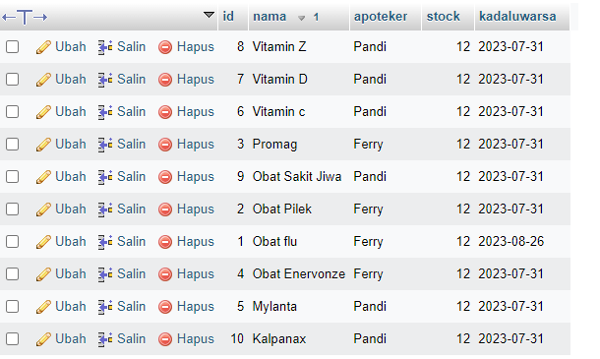

1. 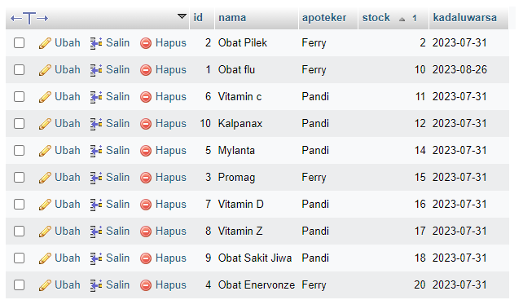SELECT * FROM `obat` ORDER BY stock ASC;
2. SELECT * FROM `obat` WHERE nama LIKE '%Vitamin D%'

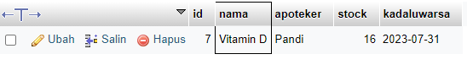

1. [SELECT](http://localhost/phpmyadmin/url.php?url=https://dev.mysql.com/doc/refman/8.0/en/select.html) * FROM `obat` WHERE nama [LIKE](http://localhost/phpmyadmin/url.php?url=https://dev.mysql.com/doc/refman/8.0/en/string-comparison-functions.html%23operator_like) '%Obat flu%';

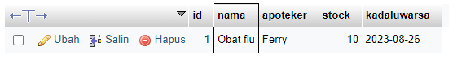

1. [SELECT](http://localhost/phpmyadmin/url.php?url=https://dev.mysql.com/doc/refman/8.0/en/select.html) id, [SUM](http://localhost/phpmyadmin/url.php?url=https://dev.mysql.com/doc/refman/8.0/en/aggregate-functions.html%23function_sum)(stock) as total FROM `obat` GROUP by id;

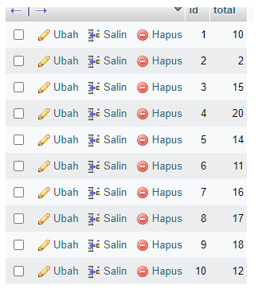

1. [SELECT](http://localhost/phpmyadmin/url.php?url=https://dev.mysql.com/doc/refman/8.0/en/select.html) * FROM `obat` WHERE [NOT](http://localhost/phpmyadmin/url.php?url=https://dev.mysql.com/doc/refman/8.0/en/logical-operators.html%23operator_not) stock = 0;

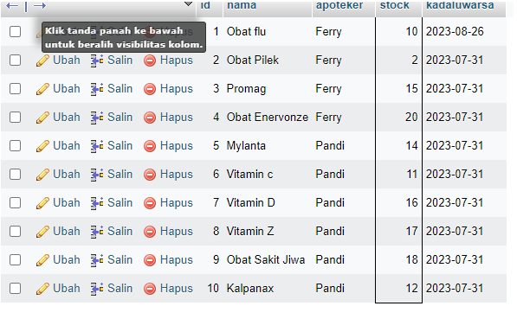

1. SELECT id, SUM(jumlah) as total FROM `transaksi` GROUP by id;

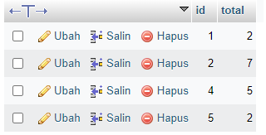

1. [SELECT](http://localhost/phpmyadmin/url.php?url=https://dev.mysql.com/doc/refman/8.0/en/select.html) id, [SUM](http://localhost/phpmyadmin/url.php?url=https://dev.mysql.com/doc/refman/8.0/en/aggregate-functions.html%23function_sum)(jumlah) as total FROM `transaksi` GROUP by obat_id;

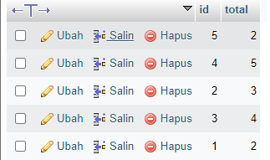

1. [SELECT](http://localhost/phpmyadmin/url.php?url=https://dev.mysql.com/doc/refman/8.0/en/select.html) kadaluwarsa, [SUM](http://localhost/phpmyadmin/url.php?url=https://dev.mysql.com/doc/refman/8.0/en/aggregate-functions.html%23function_sum)(stock) as stock FROM `obat` GROUP BY kadaluwarsa;

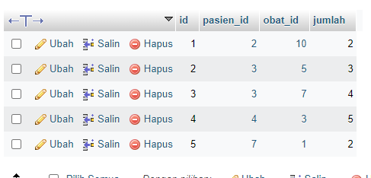

1. SELECT kadaluwarsa, SUM(stock) as stock FROM `obat` GROUP BY kadaluwarsa ORDER BY kadaluwarsa DESC;

